**Economic Growth and Development**

"Economic growth" refers to a quantitative increase in a country's output over time, usually measured by the rise in Gross Domestic Product (GDP), while "economic development" is a broader concept encompassing not only increased production but also qualitative improvements in living standards, including factors like health, education, and social well-being, making it more focused on improving people's quality of life rather than just producing more goods and services; essentially, growth is about producing more, while development is about improving lives.

Key points to remember:

* **Economic Growth:**
  + Measured by GDP increase.
  + Focuses on quantitative changes like increased production volume.
  + Can be achieved through increased capital investment, technological advancements, or labor productivity.
* **Economic Development:**
  + Includes economic growth but also considers social, political, and environmental factors.
  + Aims to improve quality of life indicators like literacy, life expectancy, and income distribution.
  + May involve policies addressing issues like poverty, inequality, and access to basic needs.

Example: A country might experience significant economic growth by building more factories and producing more goods, but this doesn't necessarily mean economic development if the benefits are not distributed evenly and social issues like poor healthcare or education persist.

**In summary**

|  |  |
| --- | --- |
| Economic Growth | Economic Development |
| * Increase in real GDP * Higher national income or output | * Economic growth + * Increase in living standards * Increase in education standards * Improve health care * Improved infrastructure * Diversification of economy |

* Economic growth means an increase in real national income / national output.
* Economic development means an improvement in the quality of life and living standards, e.g. measures of literacy, life-expectancy and health care.
* [*Ceteris paribus*](https://www.economicshelp.org/blog/glossary/ceteris-paribus/), we would expect economic growth to enable more economic development. Higher real GDP enables more to be spent on health care and education.
* However, the link is not guaranteed. The proceeds of economic growth could be wasted or retained by a small wealthy elite.

**Economic development**

Development looks at a wider range of statistics than just GDP per capita. Development is concerned with how people are actually affected. It looks at their actual living standards and the freedom they have to enjoy a good standard of living.

Measures of economic development will look at:

* Real income per head – GDP per capita
* Levels of literacy and education standards
* Levels of healthcare e.g. number of doctors per 1000 population
* Quality and availability of housing
* Levels of environmental standards
* Life expectancy.

**Absolute Poverty**. Do people have sufficient resources to maintain a healthy diet and basics of life such as shelter? Economic growth may be essential to enable higher incomes for people to be able to buy more food. However, economic growth doesn’t necessarily improve everyone’s living standards. Economic growth could bypass the poorest sections of society because they don’t have the ability to take part. A key issue is whether the benefits of economic growth are equitably distributed amongst different groups of society.

**Education standards.** e.g. literacy rates. Economic growth may enable more money to be spent on education. However, there is no guarantee that the proceeds of growth will be used to improve education standards. There is often a weak correlation between GDP and literacy rates.

**Environmental standards.** Economic growth can actually harm the environment and people’s living standards. For example, higher output could cause more pollution. If higher growth involves cutting down forests – this could have adverse environmental consequences in long-term.

**Transport / Infrastructure**Economic development would require improvements in infrastructure and transport. This may be important for regions that may be cut off from the main areas of economic growth.

**Measures of economic development**

Measuring economic development is not as precise as measuring GDP because it depends on what factors are included in the measure.

There are several different measures of economic development, such as the [Human development index (HDI)](https://www.economicshelp.org/blog/glossary/human-development-index/)

**Human development index (HDI)**

[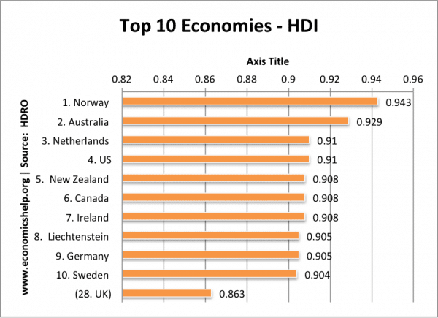](https://www.economicshelp.org/wp-content/uploads/2013/09/hdi-top10.png)

**The HDI combines**:

1. Life Expectancy Index. Average life expectancy compared to a global expected life expectancy.
2. Education Index
   1. mean years of schooling
   2. expected years of schooling
3. Income Index (GNI at PPP)

more on [Human development index (HDI)](https://www.economicshelp.org/blog/glossary/human-development-index/)

**Factors affecting economic growth in developing countries**

* Levels of infrastructure – e.g. transport and communication
* Levels of corruption, e.g what percentage of tax rates are actually collected and spent on public services.
* Educational standards and labour productivity. Basic levels of literacy and education can determine the productivity of the workforce.
* Levels of inward investment. For example, China has invested in many African countries to help export raw materials, that its economy needs.
* Labour mobility. Is labour able to move from relatively unproductive agriculture to more productive manufacturing?
* The flow of foreign aid and investment. Targeted aid, can help improve infrastructure and living standards.
* Level of savings and investment. Higher savings can fund more investment, helping economic growth.

**Economic growth without development**

It is possible to have economic growth without development. i.e. an increase in GDP, but most people don’t see any actual improvements in living standards. This could occur due to:

1. Economic growth may only benefit a small % of the population. For example, if a country produces more oil, it will see an increase in GDP. However, it is possible, that this oil is only owned by one firm, and therefore, the average worker doesn’t really benefit.
2. Corruption. A country may see higher GDP, but the benefits of growth may be syphoned into the bank accounts of politicians
3. Environmental problems. Producing toxic chemicals will lead to an increase in real GDP. However, without proper regulation, it can also lead to environmental and health problems. This is an example of where growth leads to a decline in living standards for many.
4. Congestion. Economic growth can cause an increase in congestion. This means people will spend longer in traffic jams. GDP may increase but they have lower living standards because they spend more time in traffic jams.
5. Production not consumed. If a state-owned industry increases output, this is reflected in an increase in GDP. However, if the output is not used by anyone then it causes no actual increase in living standards.
6. Military spending. A country may increase GDP by spending more on military goods. However, if this is at the expense of health care and education it can lead to lower living standards.